Chapter 13 Laboratory Techniques name: class:
1. 掌握标准溶液的配制步骤
Equipment: balance, weighing boat, volumetric flask, wash bottle, funnel, stirring rod
Steps: weigh → transfer to volumetric flask → dissolve → fill to mark → stopper and invert
Use volumetric flask (not beaker) for accurate final volume

1. A student uses a 100 mL beaker instead of a 100 mL volumetric flask. The concentration will be: （ ）
A too high — beaker markings are less accurate.
B too low — beaker holds more than 100 mL.
C unaffected — both hold the same volume.
D either too high or too low depending on the beaker.

2. A student needs to prepare 100.0 mL of 0.500 M NaCl (58.44 g/mol).
(a) Calculate the mass of NaCl required. [1 mark]
(b) List equipment and describe the procedure. [3 marks]

2. 掌握滴定操作和误差分析
Titration equipment: buret (delivers variable volume ±0.05mL), volumetric pipet (fixed volume), conical flask
Phenolphthalein: colourless → pink at pH 8.2-10.0, suitable for strong acid-strong base titrations
Error analysis: air bubble in buret → apparent volume too large → calculated [ ] too high
Rinsing conical flask with water does NOT affect the result (moles of analyte unchanged)

1. In a titration, the buret tip contains an air bubble before titration that is expelled during titration.
The calculated [analyte] will be: （ ）
A too high.
B too low.
C unaffected.
D either too high or too low.

2. Rinsing the conical flask with distilled water (but not drying) before adding the analyte: （ ）
A makes the calculated concentration too high.
B makes the calculated concentration too low.
C does not affect the result.
D changes the endpoint colour.

3. The buret is rinsed with distilled water but NOT rinsed with the titrant before filling.
The calculated [analyte] will be: （ ）
A too high (titrant diluted, more volume needed).
B too low.
C unaffected.
D cannot predict.

4. 25.0 mL H₂SO₄ titrated with 0.100 M NaOH. 32.5 mL NaOH required. 2NaOH + H₂SO₄ → Na₂SO₄ + 2H₂O.
(a) Calculate [H₂SO₄]. [2 marks]

5. 20.0 mL HCl titrated with 0.150 M NaOH. Initial buret = 0.35 mL, final = 24.85 mL.
(a) Calculate volume delivered. [1 mark]
(b) Calculate [HCl]. [2 marks]

滴定实验步骤 (Titration Procedure): (1) rinse buret with titrant, fill, remove air bubble; (2) pipet known volume of analyte into conical flask; (3) add 2-3 drops of indicator; (4) add titrant slowly while swirling flask; (5) near endpoint, add dropwise; (6) record final buret reading at color change
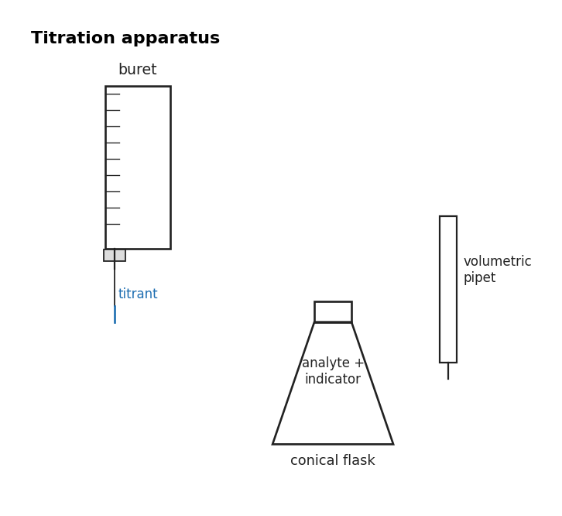
图 C₁3-2：滴定操作装置示意图（对应第 2 考点）
Equivalence point: stoichiometrically equivalent amounts of acid and base have reacted (calculated from moles)
Endpoint: observable color change of indicator; should be close to equivalence point
Indicator selection: phenolphthalein (pH 8.2-10, strong acid-strong base/weak acid-strong base); methyl orange (pH 3.1-4.4, strong acid-weak base); bromothymol blue (pH 6.0-7.6, near-neutral)
Redox titration: uses redox reaction (e.g. KMnO₄ titration — MnO₄⁻ is self-indicating, purple → colorless at endpoint)
Titration curve: pH vs volume of titrant added; strong acid-strong base → curve is steep near equivalence at pH 7
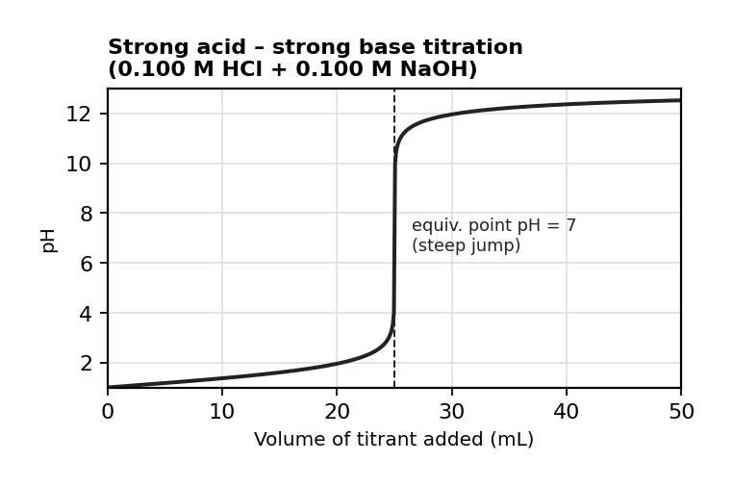
图 C₁3-1：强酸-强碱滴定曲线（对应第 2 考点）

4. In a redox titration, 25.0 mL of Fe²⁺ solution is titrated with 0.0200 M KMnO₄.
The balanced equation is:
MnO₄⁻ + 5Fe²⁺ + 8H⁺ → Mn²⁺ + 5Fe³⁺ + 4H₂O.
If 22.5 mL of KMnO₄ is required, what is [Fe²⁺]? （ ）
A 0.0180 M
B 0.0900 M
C 0.225 M
D 0.0450 M

5. Which indicator is most appropriate for titrating a weak acid (e.g. CH₃COOH) with a strong base (e.g. NaOH)? （ ）
A Methyl orange (pH range 3.1-4.4)
B Bromothymol blue (pH range 6.0-7.6)
C Phenolphthalein (pH range 8.2-10.0)
D Any indicator works equally well.

3. 掌握水合物的实验测定
Hydrated salt: CuSO₄·xH₂O → CuSO₄(s) + xH₂O(g) upon heating
x = moles H₂O lost / moles anhydrous salt
Heat to constant mass: repeat heating until mass doesn't change

1. 2.50 g CuSO₄·xH₂O heated to constant mass. After heating: 1.60 g. (CuSO₄=159.62, H₂O=18.02)
(a) Calculate mass of water lost. [1 mark]
(b) Determine x. [2 marks]

